**Advanced Petrophysics**

**PGE 381L, Fall 2023**

**Unique Number: 20215**

**Homework Assignment No. 4**

September 28, 2023

Due on Tuesday, September 10, 2023, before 11:00 PM

Name: ­­­­­­­­­­_____________________________________________________________________­__

UT EID: ­­­­­­­­­­ ____________________________________________________________________

**Objectives:**

1. To practice application of Darcy’s law

**Coursework Copyright Policy:** Handouts and data used in this course are copyrighted. The designation "handouts" includes all the materials generated for this class, which include but are not limited to syllabus, quizzes, data, exams, solution sets, laboratory problems, in-class materials, PowerPoint presentations, PDF files, review sheets, additional problem sets, and digital material. Because these materials are copyrighted, students do not have the right to copy them, reproduce them (including digital reproductions), post them on the web, or share them with anyone by either manual or electronic means unless you are expressly granted permission by the instructor.

**Note:** Please scan your homework assignment and upload it as one pdf file on the Canvas website before the deadline. Please name your homework document as follows:

*PGE381L_2023_Fall _HW04_lastname_name.pdf*

Example: PGE381L_2023_Fall_HW04_Heidari_Zoya.pdf

**Question 1:** A vertical well is drilled in an oil-bearing reservoir. This reservoir can be considered as isotropic and homogeneous, with average porosity and permeability of 15% and 40 mD. Mud-filtrate invasion has caused damage to the near-wellbore region and has decreased the permeability of the invaded zone to 5 mD. Assume that the depth of damage into the reservoir is approximately 1 ft.

Oil viscosity = 4 cp

Reservoir thickness = 35 ft

Wellbore radius = 0.3 ft

External drainage radius = 1000 ft

Reservoir pressure = 5000 psi

Bottom-hole pressure = 2200 psi

Answer the following questions:

1. Estimate the effective horizontal permeability of the reservoir.
2. Estimate the initial rate of production. Report the estimate of production in reservoir bbl per day.

**Question 2:** A core prepared for a series of flow experiments consists of a 15 cm long piece of 1 mD rock and a 15 cm long piece of 10 mD rock joined in series (**Figure 1**). Pressure taps are located 7.5 cm from each end of the core. The cross-sectional area of the core is 20 cm2. The 1 mD core is at the upstream end (where fluid is being injected). The downstream pressure is kept at atmospheric pressure. Brine of viscosity 1 cp is injected into the core at steady-state rate of 5 cm3/hr. What will be the gauge pressures P1 and P2 (in atm) at the pressure taps?



**Figure 1:** The core setup prepared for flow experiments

**Question 3:** The following figure shows an inclined steady-state flow experiment for an incompressible liquid in a porous medium. The rock and fluid properties are as follows:

Absolute permeability = 2D

Density of the liquid = 1.024 g/cc

Cross sectional area = 100 cm2

Viscosity of the liquid = 1.5 cp

Gravitational acceleration = 981 cm/s2

Mean grain diameter of the porous medium = 1/16 mm

Answer the following questions:

1. Is there flow through the porous medium? Justify your answer and determine the direction of flow.
2. If there is flow, what is the direction of flow in this porous medium?
3. Estimate the volumetric flow rate.
4. If there is flow, is the flow considered as Darcy or non-Darcy flow? Justify your answer with appropriate calculations.

**Question 4:** Figure 1 shows a falling head permeameter (Domenica and Schwartz, 1990) for determining the permeability of a core using a nonreactive liquid. Answer the following questions:

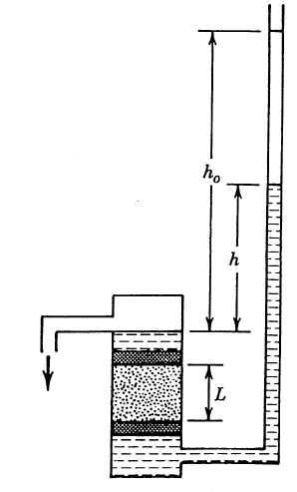

**Figure 1:** Falling head permeameter (Domenica and Schwartz, 1990)

1. Drive the differential equation for the instantaneous height h in terms of the following system variables:

Cross sectional area of the core = A

Length of the core = L

Core permeability = k

Liquid density = ρ

Liquid viscosity = µ

Cross sectional area of eth liquid manometer = a

Gravitational acceleration = g

Time = t

Height at t=0 = h0

1. Solve the differential equation you derived in part (a).
2. Given the set of h versus t experimental measurements listed in Table 1 and the following information about the rock/fluid samples and experimental setup, determine the absolute permeability of the core sample.

|  |  |
| --- | --- |
| **Table 1:** Experimental data for Question 1 | |
| **t (s)** | **h (cm)** |
| 0 | 100.0 |
| 100 | 96.1 |
| 500 | 82.0 |
| 1000 | 67.0 |
| 2000 | 45.0 |
| 3000 | 30.0 |
| 4000 | 20.0 |
| 5000 | 13.5 |

Core length = 10 cm

Core diameter = 5 cm

Diameter of manometer = 1 cm

Brine density = 1.02 g/cc

Brine viscosity =1 cp

Gravitational acceleration = 981 cm/s2

**Optional Questions:**

**You do not need to submit solutions to the following questions. You can solve the following questions for the purpose of practicing. They will not be graded.**

**Question 5:** Solve question 3.10 in the “Advanced Petrophysics” textbook.

**Question 6:** Use Darcy’s law to estimate average permeability for the following laminated structures.

|  |  |
| --- | --- |
| **Case 1:** Linear beds in series | **Case 2:** Linear beds in parallel |
| **Case 3:** Radial beds in series | **Case 4:** Radial beds in parallel |

**Question 7:** Figure 3 shows an apparatus for determining the permeability of a core using a nonreactive liquid. (Question 3.13 in your textbook)

1. 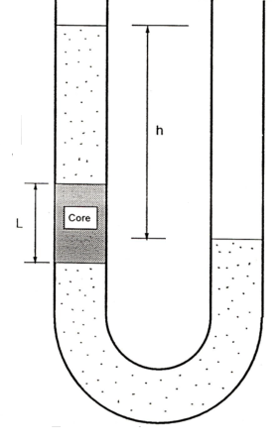Derive the differential equation for the instantaneous height h in terms of the pertinent system variables and parameters. Use the following symbols in your derivation:

Cross sectional area of the core and the U tube = A

Length of core = L

Core permeability = k

Liquid density = ρ

Liquid viscosity = μ

Gravitational acceleration = g

Time = t

Height at t = 0 = ho

1. Solve the differential equation you derived in part (a) analytically.
2. The following data were obtained in the experiment using brine:

Time (s) h (cm)

0 100.0

1000 67.0

3000 30.0

5000 13.5

Additional data are as follows:

Length of core = 10 cm

Core and U-tube diameter = 2 cm

Brine density = 1.02 g/cm3

Brine viscosity = 1 cp

Gravitational acceleration = 981 cm/s2

Based on the theory you have derived in parts (a) and (b), determine the permeability of the core and state its units.